GAME DESCRIPTION
Pinata Beat 1000



GAME INTRODUCTION
- THIS IS A 5-REEL SLOT MACHINE.

PAYTABLE
- WILD SYMBOL
- [WW] SUBSTITUTES FOR ALL SYMBOLS EXCEPT [Scatter].
- SCATTER SYMBOL
- {3} OR MORE [Scatter] APPEARING ANYWHERE WILL TRIGGER THE FREE GAME FEATURE AFTER ALL CASCADES ARE COMPLETE.
- PAY TABLE
[M1] 5 - 5000 | [M2] 5 - 2000 | [M3] 5 - 1000
[M1] 4 - 1250 | [M2] 4 - 500 | [M3] 4 - 250
[M1] 3 - 250 | [M2] 3 - 100 | [M3] 3 - 75
[M4] 5 - 750 | [M5] 5 - 500 | [A] 5 - 250
[M4] 4 - 200 | [M5] 4 - 100 | [A] 4 - 50
[M4] 3 - 50 | [M5] 3 - 25 | [A] 3 - 10
[K] 5 - 250 | [Q] 5 - 250 | [J] 5 - 250
[K] 4 - 50 | [Q] 4 - 50 | [J] 4 - 50
[K] 3 - 10 | [Q] 3 - 10 | [J] 3 - 10

CASCADING FEATURE
- AFTER EACH WIN EVALUATION, WINNING SYMBOLS ARE REMOVED AND THE SYMBOLS ABOVE FALL DOWN TO FILL THE EMPTY POSITIONS.
- AFTER THE SYMBOLS CASCADE DOWN, NEW WINNING COMBINATIONS ARE EVALUATED AGAIN. THIS PROCESS REPEATS UNTIL NO NEW WINNING COMBINATIONS ARE FORMED.
- DURING CASCADING, IF A REEL ALREADY CONTAINS {1} [Scatter], NO MORE [Scatter] WILL APPEAR ON THAT REEL.

MULTIPLIER FEATURE
- GOLDEN FRAMED SYMBOLS MAY CARRY A MULTIPLIER VALUE. THE MULTIPLIER LEVELS ARE: {×2}, {×3}, {×5}, {×8}, {×10}, {×15}, {×20}, {×25}, {×50}, {×100}, {×500}, {×1000}.
- THE MULTIPLIER IS ONLY COLLECTED AND ADDED TO THE ACCUMULATED TOTAL WHEN THE GOLDEN FRAMED SYMBOL WITH A MULTIPLIER ACTUALLY PARTICIPATES IN A WIN AND IS CLEARED.
- WHEN NO MORE CASCADES CAN OCCUR, IF ANY MULTIPLIER WAS COLLECTED DURING THIS SPIN, THE TOTAL ACCUMULATED MULTIPLIER IS APPLIED TO THE TOTAL WIN OF THIS SPIN.
- IN THE BASE GAME, REEL 3 MAY RANDOMLY APPEAR AS AN ENTIRE REEL OF GOLDEN FRAMED SYMBOLS WITH MULTIPLIERS.
- DURING FREE GAME, REEL 3 IS GUARANTEED TO BE AN ENTIRE REEL OF GOLDEN FRAMED SYMBOLS WITH MULTIPLIERS.

GOLDEN FRAMED FEATURE
- GENERAL SYMBOLS ON REELS 2, 3, AND 4 MAY APPEAR WITH A GOLDEN FRAME.
- GOLDEN FRAMED SYMBOLS PAY THE SAME AS THEIR ORIGINAL SYMBOL.
- IF A GOLDEN FRAMED SYMBOL PARTICIPATES IN A WIN AND IS CLEARED, THAT POSITION CONVERTS INTO A [Wild].
- [Wild] DOES NOT APPEAR NATURALLY ON THE REELS AND IS MAINLY GENERATED THROUGH GOLDEN FRAME CONVERSION.

FREE GAME FEATURE
- WHEN ALL CASCADES ARE COMPLETE, IF THE FINAL REELS SHOW {3}, {4}, OR {5} [Scatter], THE FREE GAME FEATURE IS TRIGGERED WITH {15}, {17}, OR {19} FREE SPINS RESPECTIVELY.
- DURING FREE GAME, THE ACCUMULATED MULTIPLIER IS NOT RESET BETWEEN SPINS AND IS CARRIED OVER UNTIL THE ENTIRE FREE GAME ENDS.
- AFTER ENTERING THE FREE GAME, INCLUDING RETRIGGERING, THE MAXIMUM NUMBER OF FREE SPINS IS {50}.
- FREE GAME CAN BE RETRIGGERED. RETRIGGERING FOLLOWS THE SAME CONDITIONS: {3}, {4}, OR {5} [Scatter] WILL ADD {15}, {17}, OR {19} FREE SPINS RESPECTIVELY.

EXTRA BET
- PLAYER MAY SELECT EXTRA BET MODE TO SPIN. EXTRA BET COSTS {2}X THE TOTAL BET.
- UNDER EXTRA BET, THE PROBABILITY OF TRIGGERING FREE GAME IS {5} TIMES THAT OF NORMAL MODE.

BUY FEATURE
- BUY FEATURE CAN BE PURCHASED BY USING A VALUE EQUAL TO {75}X TOTAL BET.
- PURCHASING THE BUY FEATURE GRANTS ENTRY INTO FREE GAME WITH STANDARD FREE GAME RULES. NO SPECIAL GUARANTEED REELS OR CONFIGURATIONS APPLY.

OP JACKPOT
- OP JACKPOT FEATURE IS TRIGGERED RANDOMLY BY {1} OR MORE [C1] ON THE REELS.
- DURING OP JACKPOT FEATURE, THERE ARE {12} [COIN] WHICH CONSIST OF [GRAND], [MAJOR], [MINOR] AND [MINI].
- SELECT A [COIN] TO REVEAL [GRAND], [MAJOR], [MINOR],OR [MINI].
- IF PLAYER GETS {3} SAME JACKPOT SYMBOLS WILL WIN THE JACKPOT AND CALCULATE TOTAL WINNINGS.
- [GRAND] IS LINKED PROGRESSIVE JACKPOT. IF THE SINGLE GAME BET OPTION IS {2.00} OR ABOVE, THE PLAYER WILL UNLOCK [GRAND].
- [MAJOR] IS LINKED PROGRESSIVE JACKPOT. IF THE SINGLE GAME BET OPTION IS {2.00} OR ABOVE, THE PLAYER WILL UNLOCK [MAJOR].
- [MINOR] WILL CHANGE IF THE PLAYER SELECTS DIFFERENT BET OPTION.
- [MINI] WILL CHANGE IF THE PLAYER SELECTS DIFFERENT BET OPTION.

LINE GAME
- THE GAME HAS {20} FIXED PAY LINES.
- WINNING COMBINATIONS MUST START FROM REEL 1 AND RUN CONSECUTIVELY FROM LEFT TO RIGHT.
- ONLY THE HIGHEST WIN PER LINE IS PAID.
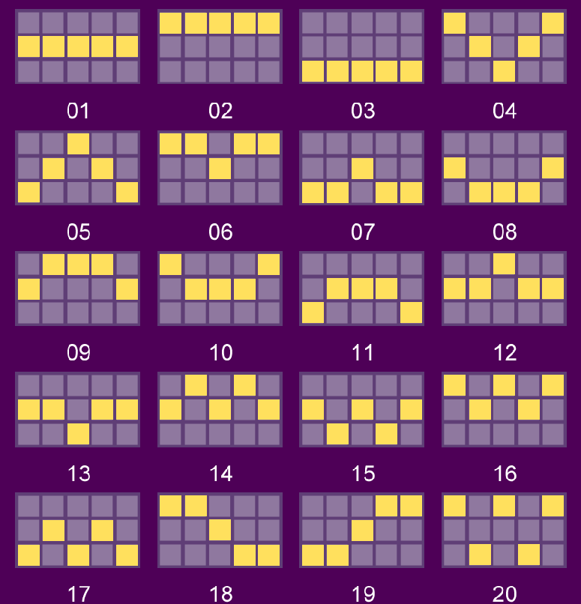

GAME RULES
- SELECT BET OPTION YOU WISH TO PLAY.
- ALL WINS ARE MULTIPLIED BY BET OPTION EXCEPT PROGRESSIVES BONUSES.
- MALFUNCTION VOIDS ALL PAYS AND PLAYS.
- IF THE PLAYER LOSES CONNECTION DURING THE FREE GAME FEATURE, THE SYSTEM WILL CALCULATE THE GAME RESULTS AUTOMATICALLY AND THE WINNING PRIZES WILL BE ADDED INTO THE BALANCE.
- THE GAME HAS 5 REELS AND 3 ROWS WITH {20} FIXED PAY LINES. WINNING COMBINATIONS ARE EVALUATED CONSECUTIVELY FROM LEFT TO RIGHT.
- ONLY THE HIGHEST WIN PER LINE IS PAID.

